TEACHER’S NOTES
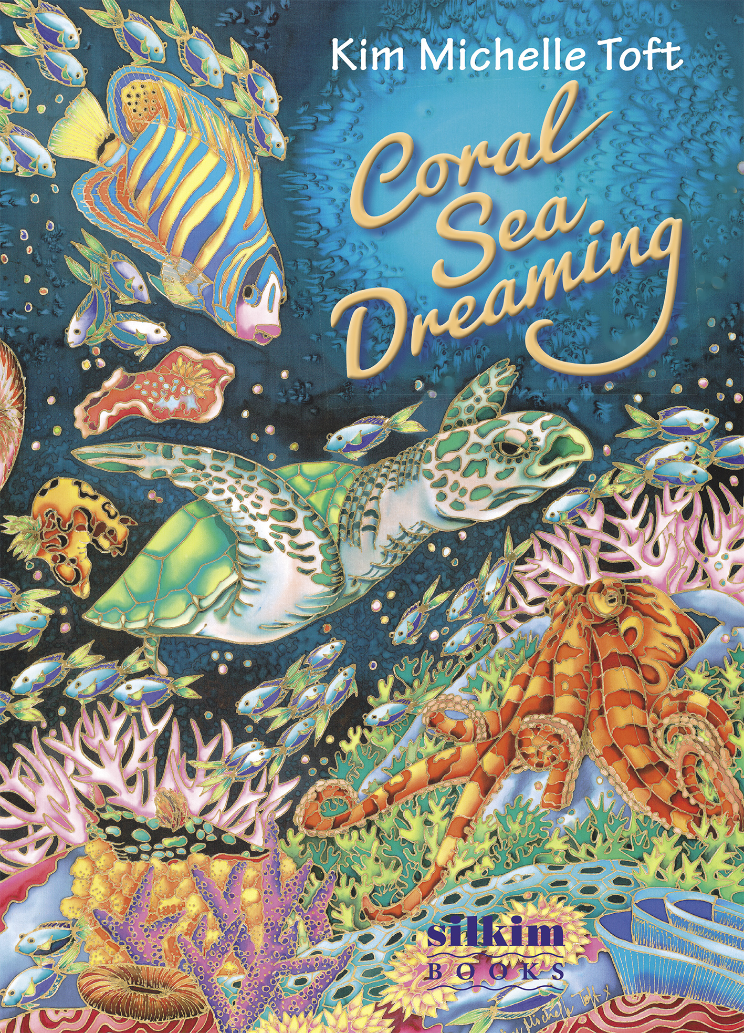
TITLE: Coral Sea Dreaming: The Picture Book
AUTHOR: Kim Michelle Toft
ILLUSTRATOR: Kim Michelle Toft
PUBLISHER: Silkim Books
PRICE: $24.95
ISBN: 9780994238849
PUBLICATION DATE: July 2017

Coral Sea Dreaming: The Picture Book is written in classic rhyme and focuses on the reef at night. Each sea creature depicted in the book is active at night on the reef.
The text presents facts about the animal and looks at the human impact on the reef and its future. An excellent springboard for discussion on coral reefs and their preservation, nocturnal animals and their role on the reef.
Each detailed illustration in the book is hand painted onto silk.
About the Book
The cover is a celebration of reef creatures and corals , the height of activity just as the reef is at night. The deep green/blue background on the cover suggests the ‘after hours’ and the gold foil title mirrors the gold ‘gutta’ edge around the outside edge of all the images.
A photo of Kim Michelle Toft on the back cover , shows Kim painting the cover which is also one of the silk illustrations from the book. Also on the back cover, the “Bonus” information directs the reader to film footage of the creatures featured in the book. All the short 2 minute videos of each creature can be viewed at channel.coralseadreaming.com . This footage was supplied by world renowned underwater cinematographer and conservationist David Hannan.
The end pages reflect the silence and expansive feeling of the underwater world. The expansive blue ocean contrasts dramatically with the colourful fringe of the coral and fish. The light source of the moonlight on the front end page is in the bottom left hand corner and on the back end pages it is in the top right hand corner showing that the moon moves in the night sky and changes it position when filtering through the water.
The half title page introduces the reader to the concept of dreaming at night.
I had a dream last night.
On the half title page the same background image is used on the end pages without the coral. The curved text also reflects a trance-like and ‘dreamy’ state.
The titlepage then starts to introduce activity with a large school of swirling, tiny silhouetted fish.
Additional information in the back 8 pages of the book looks at each animal in greater detail , looking at both behavioural and nocturnal habits of the animals . There is also information about the human impact on the reef and how we can help save the reef.
The notes will look at each double page under the following categories-
- Main Animals/Concepts
- Illustration
- Questions / Discussion
- Suggested Activity

The overall educational concepts are

- ENVIRONMENTAL STUDIES – human impact on the reef
- SCIENCE- nocturnal sea creatures and behaviours , coral reefs
- ART – silk paintings
- FILM – actual footage of the sea animals

As I lay my head to sleep
The colour blue begins to seep
Inside my mind , inside my soul
Feeling weightless, lost control.

Main Resources /Concepts
- SCIENCE – The ocean and the feeling of floating in the ocean and how that compares to drifting off to sleep.

Illustration
- A dark shadow encroaches in the top right hand corner, suggesting the onset of night and sleep. The curved text heightens the feeling of weightlessness.

Questions / Discussion

- How do you feel when you are in the water?
- What can you hear when you are underwater?
- How do you feel when you are about to go to sleep?
Suggested Activity
- Experiment with a variety of objects to see which floats and which sink when placed in a bucket of water.
- Next time the child is swimming get them to note how they feel and how they feel just before they go to sleep. How does that compare?

Mysterious shadows glide on by
Suspended magically in a liquid sky
Flying gracefully, flying free
Through my midnight fantasy

Main Animals/Concepts
- ANIMALS - Sharks and Rays
- SCIENCE -How silhouettes are formed, coral reefs
- ART - Perspective
Illustration
- Why do you think the illustrator put the animals in silhouette? And why are some smaller than the other shadows?
A : The view is from under the animals and the light coming through the surface of the water is putting them into shadow or silhouette form. The different sizes are due to some animals being closer and further away.

Questions / Discussion
- What animals have been introduced to this page? A: Sharks and rays
- What type of shark is pictured? A: Hammerhead
- How many different types of rays are there? A: 2 , the stingray and manta ray
- Where would you be in the ocean if you were looking at this scene? A: At the bottom looking up
- Is the ocean like a ‘liquid sky’? Why? A: Both are vast and appear to be blue in colour

Suggested Activity
- Photocopy and cut out silhouettes of sting rays in black cardboard and hang from the ceiling or in front of a large blue backdrop. Discuss how they look like they are flying because of their ‘wings’.
- Investigate hammerhead sharks and why their heads are shaped like a hammer. Refer to the information in the back of the book and watch the video of rays and sharks at channel.coralseadreaming.com

The reef and fish begin to move
Polyps popping to a funky groove
Swirling up, swirling round
Creating life without a sound.

Main Animals/Concepts
- ANIMALS – Coral polyps, epaulette or ‘walking’ shark, moorish idol and anthias
- SCIENCE – The activity on the reef at night

Illustration
- This illustration is very different from the previous 2 illustrations, how is it different?
A: It is a close-up view and there is much more detail, movement and colour.

Questions / Discussion
- What kind of animal is hiding on the floor of the reef, hiding amongst the coral?
A: A shark – the epaulette or commonly known as the ‘walking’ shark
- How does it walk? Research in the back of the book to find the answers
Suggested Activity
- Children lie on the floor and crawl around on their stomachs using only their elbows and knees to move around, mimicking the ‘walking’ shark.
- Watch the video about epaulette sharks on channel.coralseadreaming.com

Sea slugs shimmy to this rhythmic tune
Under the light of the silvery moon
Swaying left, swaying right
A salty salsa throughout the night.

Main Animals/Concepts
- ANIMALS – Sea slugs or nudibranchs and a variety of corals
- SCIENCE – Coral reefs

Illustration
- How many nudibranchs can you find? A: 18
- How many are swimming and how many are crawling across the coral?
A: 13 are swimming and 5 are crawling

Questions /Discussion
- What is the scientific name for sea slugs? A: Nudibranchs
- Which 2 nudibranchs are known as Spanish Dancers? Google to find pictures of Spanish Dancer nudibranchs.
A: The 2 red and white sea slugs in the top right hand corner.

Suggested Activity
- Watch the video at channel.coralseadreaming.com and then create a dance like the Spanish Dancer nudibranchs. Use some ‘aquatic’ music to accompany the dance.

Then alien angels sweep into view
Remarkable animals that can change on cue
Touching tentacles, touching souls
Soon to vanish in a deep dark hole.

Main Animals/Concepts
- ANIMALS – Octopus , corals, clownfish and anthias
- SCIENCE – Forms of camouflage ,coral reefs

Illustration
- Why do you think the illustrator has the 2 octopuses touching tentacles? And where has she placed the 2 octopuses on the page?
- Can you find a fish hiding in the coral? A: clownfish
- Where does a clownfish live? A: anemone
- The little fish along the bottom are named anthias , how many can you find? A: 21
Questions / Discussion
- How many tentacles does an octopus have? A: 8
- What other animal has 8 legs? A: spiders
- Why do you think the author has described the octopus as ‘alien angels’? A: Octopuses have a bizarre appearance and can change their size. shape and colour in an instant.
- What other animals use camouflage to help protect themselves?
Suggested Activities
- Cut out the shape of an octopus’ body and 8 tentacles then colour or paint. Attach the legs using a splay pin so that the tentacles can move ( splay pin like those used for clock hands).

Where a moray eel gives quite a scare
A character found in a wild nightmare
With an unlikely ally, an unlikely mate
A cleaner shrimp working on their late night date.

Main Animals/Concepts
- ANIMALS – Moray eel, cleaner shrimp and corals
- SCIENCE – Symbiotic relationships in the animal kingdom, coral reefs

Illustration
- What has the illustrator done to make it feel like a cave or hole? A: Surrounded the animals with coral and used a ‘tunnel’ of light through the darker green water.
- What are the colours used for the corals? A: Reds, oranges, yellows and olive greens, all very warm colours to help set the mood of darkness.
Questions /Discussion
- Do you think the moray eel is scary?
- Does the cleaner shrimp look scared? Why not? A: Research in the back of the book and discuss symbiotic relationships
- What other animals have symbiotic relationships? A: Clownfish and anemone and a shark and cleaner wrasse.

Suggested Activity
- Draw and colour a piece of coral and then cut a slit in the coral. Then draw, colour and cut out a moray eel which is smaller than the coral .Thread the head and body through the slit in the coral to mimic the eel coming in and out of its hole.

Sssssh…..Parrotfish is sleeping inside its bubble bed
While a lionfish lurks where others fear to tread
Hunting for its meal, hunting for its prey
Searching through the coral ‘til the break of day.

Main Animals/Concepts
- ANIMALS – Lionfish, parrotfish, corals and anthias
- SCIENCE – Defence mechanisms animals use to hunt and protect themselves ,coral reefs

Illustration
- How has the illustrator divided the drawing? A: Almost in half, one half very busy with coral and fish and the other half highlighting the lionfish and the open ocean.

Questions /Discussion
- Why is the parrotfish in a ‘bubble’ bed? A: Research in the back of the book
- What is it about the lionfish that makes it such a dangerous predator? A: Its poisonous spines which stun its prey and the ability to strike its prey at lightning speed.

Suggested Activity
- The spines of the lionfish look a lot like feathers. Using feathers, stick them around the drawing of a body of the lionfish and paint the tip of each feather to represent the poison.

A wise old mariner cruises slowly on by
Not bothered by the action or the changing tide
Many miles she has travelled, many miles still to go
An epic sea journey through life’s tos and fros.

Main Animals/Concepts
- ANIMALS – Green sea turtles
- SCIENCE – Animal migration and endangered species ,oceans

Illustration
- How does this illustration vary from the previous 2 illustrations? A: The lack of detail and business gives it the feeling of the open ocean and silence with the turtle floating effortlessly through the water.
Questions / Discussion
- What is a mariner? (look up the answer in the dictionary)
- Why has the author described the turtle as a ‘wise old mariner’? A: The marine turtle has been around since the dinosaurs and is one of the oldest living creatures on the planet, travelling thousands of kilometres to mate, breed and feed.
- What type of turtle is pictured? A: Green sea turtle
- What are some other sea turtles? A: Loggerheads, leatherbacks , hawksbill turtles, flatback turtles, kemp’s ridley turtles and olive ridley turtles

- What does it mean when an animal is endangered? A: The number of that particular species is declining faster than numbers can be replenished.
- All marine turtles are endangered, what are the main causes? A: Research the answers in the back of the book .

Suggested Activity
- Visit an aquarium or rescue centre for turtles.
- Watch the video of turtles at channel.coralseadreaming.com
- Cut out pictures of turtles and stick them on a large sheet of painted blue card or paint a couple of meters of silk with blue dye and while it is still wet place rock salt onto the blue dye to create the ‘bubble’ effect. When the silk is dry remove the rock salt and pin turtles to the silk.
- Watch the 2 videos of Kim silk painting at www.kimtoft.com.au

Extraordinary creatures continue to parade
Over carpets of colour the coral has made
For millions of days and millions of nights
Building spectacular structures, breathtaking sights.
Main Animals/Concepts
- ANIMALS – Variety of corals, angelfish, green sea turtle, octopus, nudibranchs, nautilus shell, anthias, bannerfish and a lobster
- SCIENCE – How do corals grow and survive
- GEOGRAPHY – The Great Barrier Reef
Illustration
- How does this illustration differ from the previous illustration? A: It is full of colour and animals all swimming in a very busy scene.
- How many sea slugs or nudibranchs can you find? A: 8
- What other animals are in the illustration? A: Corals, angelfish, green sea turtle, octopus, nautilus shell, lobster and anthias.
Questions / Discussion
- How does coral grow? A: Research answer in the back of this book
- Why do so many different sea creatures live on a coral reef? A: The nutrient rich waters attract a wide variety of animals which supply food for larger animals and so on, creating a complex food chain. The reef is one of the most biologically diverse habitats on the planet.

- What is the largest coral reef in the world? A: The Great Barrier Reef
Suggested Activity
- Create a 3 dimensional collage by cutting out coloured paper, tissue and cardboard into the shapes of different corals and stick the shapes on a long piece of painted blue cardboard. Cut and colour fish to stick in between the coral.
- Watch the video of coral spawning at channel.coralseadreaming.com

The sun slowly rises and so must I
My coral sea dream all gone with a sigh
A world so ancient, a world so rare
Its future so fragile without love and care.

Main Animals/ Concepts
- ANIMALS – Human beings
- SCIENCE – Ocean and reef conservation
Illustration
- Why has the illustrator put the person as a silhouette? A: To mimic the page when the person first went to sleep and dreamed of the sharks and rays which were also painted as silhouettes.
- What direction is the person swimming?
A: Towards the light source which represents the rising sun.

Questions / Discussion
- Why does the author describe the reef as ‘ancient’ and ‘rare’? A: Coral reefs have been on the planet for millions of years and have the strangest and most diverse range of living creatures of any habitat.
- Why is the future of the reef so fragile? A: Research this using the information in the back of the book and then source other books in the library that talk about the human impact on the oceans and reefs.

Suggested Activity
- Contact an organisation that works towards saving our coral reefs and oceans ie. Australian Marine Conservation Society, WWF. Email or write to these organisations and ask them to send literature to the classroom to read and discuss.
- Paint scenes of the underwater world and then host an art auction to raise money for one of the above organisations and send a donation.

We can no longer sleep or continue to ignore
The importance of what we must urgently restore
This coral sea world, this coral sea dream
A vital ingredient in life’s precious scheme.

Main Animals/Concepts
- ANIMALS– Corals and schooling fish
- SCIENCE – Reef conversation
Illustration
- Can you find another page in the book that shows fish schooling like in this illustration? A: The titlepage
- How does the type reflect the movement on the page? A: Being placed in a spiral pattern to mimic the swirling fish mass
Questions / Discussion
- How does the ocean effect other habitats? A: The currents in the ocean affect weather patterns, the ocean supplies food for millions of people and the beauty of coral reef creates jobs for millions of people involved with tourism.
- How can we help save the reef and oceans? A: Research information in the back of this book
- Why do fish school together?
A: The swirling mass makes it harder for predators to single out individual fish. The spinning mass shift and change shape in an attempt to confuse their enemies.
Suggested Activity
- Photocopy and cut out small black fish shapes and stick in a large circle with fish overlapping onto a large piece of painted blue cardboard. Paint background with light source in the middle of the circle of blue.
- Go to a local waterway and collect rubbish.

Information Pages

Eight pages of additional information about each animal and concept is listed in the back of the book. Videos can be sourced at channel.coralseadreaming.com and www.kimtoft.com.au

Overall Book

Questions / Discussion

- Who is the author and illustrator?
- What medium has the illustrator used? (Refer to the photo on the back cover which shows a silk painting from the book in progress)
- What is your favourite illustration and why?

Author/Illustrator Background

Kim Michelle Toft has been drawing since the age of 4, her love of art has stayed with her throughout her ‘colourful’ life. Spanning over the past 53 years Kim has been a teacher in far North Queensland, a graphic designer living on the beach in Adelaide, South Australia, a full time marine and silk artist based in beautiful Northern NSW and for the past 25 years a celebrated author and illustrator, still living in beautiful Northern NSW. Her multi-award winning environmental children’s books are quite unique as they are illustrated with hand painted silks. Kim’s silk paintings are sold worldwide and have been purchased by some very famous people including the late Morris West, Mick Jagger and Jerry Hall.

Kim’s Environmental Picture Books

All Kim’s books have a strong environmental focus and reflect her love of the ocean and the coastal habitats which support it. The combination of interesting, interactive prose-style text and stunningly detailed hand painted silk illustrations have made her books internationally and nationally renowned, winning many coveted awards including-
One Less Fish – Honour Book – Children’s Book Council of Australia 1998
The World That We Want -Honour Book-Green Earth Book Awards, USA 2006
A Sea Of Words – Notable Book – Children’s Book Council of Australia 2007
Tick Tock Tick Tock What’s Up Croc? – Whitley Award for Best illustrated Children’s Book - Royal Zoological Society of NSW 2010
Recipe For Perfect Planet Pie – Shortlisted Book Golden Dragon Award , Hong Kong 2015

All Kim’s books are still in print, which is a testament to their quality.

Her past titles include:
- One Less Fish (UQP)
- Neptune’s Nursery (UQP)
- Turtle’s Song (UQP)
- The World That We Want (UQP)
- Reef Superstar (Brolly Books)
- A Sea of Words (Silkim Books)
- The Twelve Underwater Days of Christmas (Silkim Books)
- Tick Tock Tick Tock What’s Up Croc? (Silkim Books)
- Recipe For Perfect Planet Pie (Silkim Books)
- I Can Swim A Rainbow (Silkim Books)

Silkim Books was set up by Kim 11 years ago, publishing the last 6 books. Each book takes approximately 18 months to 2 years to research, draw, paint, design and produce. One hand painted silk illustration takes 2-3 weeks to produce and an original silk can measure up to 2 metres x 1 metre!

Kim visits thousands of children each year throughout Australia and Asia spreading the environmental message as well as demonstrating and teaching her unique illustration style – silk painting.

If you would like Kim Michelle Toft to visit your school please go to her website to make an enquiry visit www.kimtoft.com.au or email Kim directly info@kimtoft.com.au

All Kim’s books have just been released in Chinese on mainland China.

Coral Sea Dreaming:The Picture Book is Kim’s 11th book. She is already working on her next two books, The Forgotten Sea and The Glad Sad Book.

Author Motivation

“Being surrounded by nature has always sustained and nurtured me. Whether it’s diving under the waves, snorkelling on a coral reef, hiking through a rainforest or swimming under a desert waterfall , all of nature’s wonders continually motivate me to write and illustrate books about their preservation.
Climate change and its causes are very current and controversial topics and no matter what your personal opinion , it is still important to create a healthier planet by conserving forests , planting more trees, aiming for cool clean air and oceans and protecting animals and their habitats. By looking at and using cleaner renewable energy supplies we can go a long way to achieving this. Each day we can also put practical things into place like recycling, conserving water and electricity , planting lots of trees and removing rubbish from waterways.
This book is intended to be an introduction for children to look at different ways they can help preserve the world’s coral reefs which are all under threat.
I first bought the video of Coral Sea Dreaming by David Hannan 25 years ago and we become friends .Dave started buying my silk paintings and he has the largest single collection of my work in the world . David supplied all the photos for reference for the silk illustrations in this book. He has also created short videos of each animal and they can be viewed at channel.coralseadreaming.com
I always enjoy researching and providing additional information for the children to extend their knowledge. My goal is to get kids thinking about positive ways of helping this planet. Children are our future and therefor it is them who will ultimately make ‘greener’ decisions and create a better place to live.
My wish is that this book is put into every school in the world.”

Kim Michelle Toft

Marketing and Selling Points

- For ages pre-school to middle-upper primary
- Rhyming text and stunning hand painted silk illustrations
- Topics which are both politically current and environmentally relevant
- Bonus video footage by David Hannan
- Eight pages of child friendly information, ideal for research
- Kim Michelle Toft’s record for producing excellent educational, environmental and visually beautiful children’s books. All still in print.

