**Education and Teacher’s Notes**

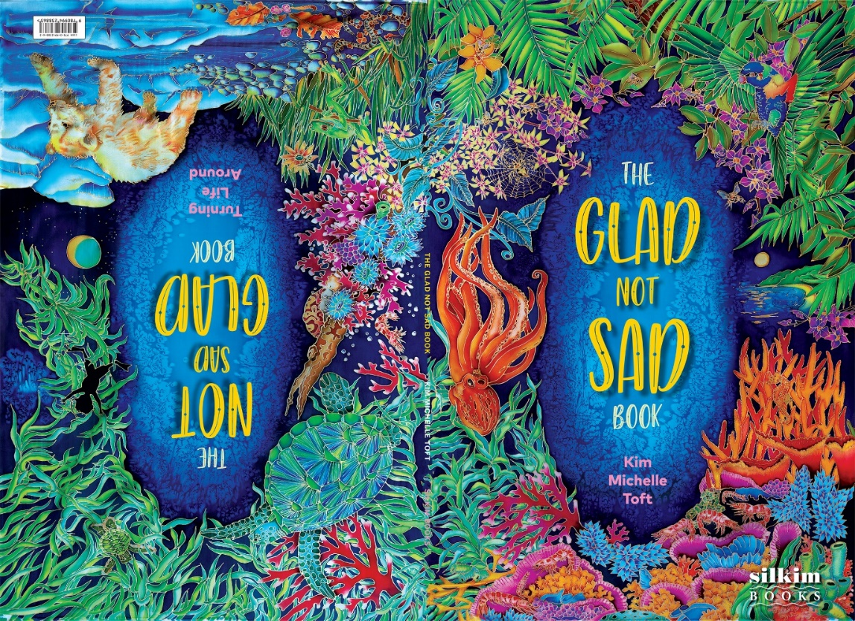

**TITLE:** The Glad Not Sad Book **AUTHOR:** Kim Michelle Toft  **ILLUSTRATOR:** Kim Michelle Toft **PUBLISHER:** Silkim Books **ISBN:** 978-0-9942388-6-3 HC **PUBLICATION DATE:**  July 2024

***The Glad Not Sad Book*** is a book with two covers, but one giant message, the power of Nature to make us feel glad and not sad. The book can be read from either the front cover or the back cover, into the middle, where the spiralling text prompts the reader to turn the book around. *And even when the world feels a little upside down, I’m glad that Nature’s power can turn it all around.*

The front and back covers depict all the animals featured in the book. The back cover also has the phrase, *Turning Life Around* instead of the author and illustrator’s name, *Kim Michelle Toft*, which is on the front cover. Turning life around for the better, is something Nature can help us do.

Each detailed illustration in the book is hand painted onto silk. Each illustration measures 120cm x 80cm and takes approximately 2 to 3 weeks to complete.

The **end pages** are painted in a swirling pattern which alludes to the ying yang symbol. Ying yang is two great opposites but complimentary forces at work in the universe. Ying Yang energy is the balance of life.

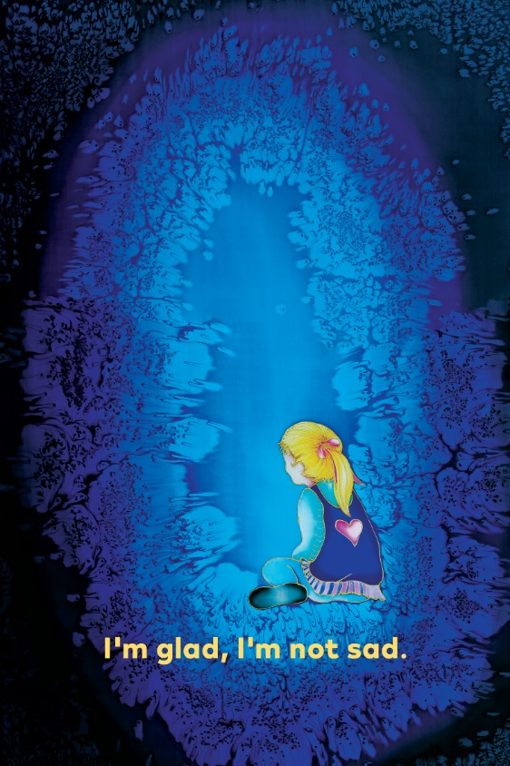 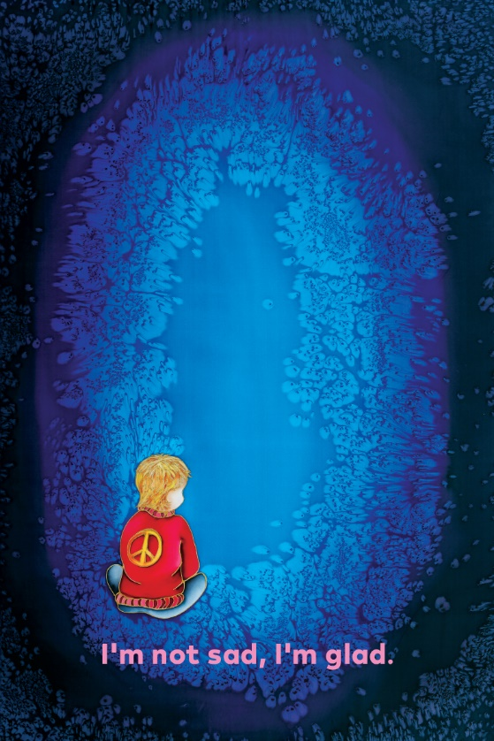 The **half title page** pictures a girl sitting looking out at the big, blue void of the world and reads, ***I’m glad, I’m not sad.***The girl in the illustration represents my daughter Casey Elle, when she was a little girl. She is now 32 years old. The title page at the back of the book reads, ***I’m not sad, I’m glad****.* It pictures a little boy looking into the void and represents my grandson Leo, who is 2 years old. My other grandson, Max, was not born when I completed the illustrations for the book. The symbols of love and peace are shown on the clothing of the children. The heart is on the girl’s top and the peace sign is on the boy’s jumper.

**About the Book**

*The Glad Not Sad Book* can be looked at in 7 main subject areas:

* Animal Groups
* Habitat and Plant Life
* The Environment
* Counting 1 – 12
* Grammar
* Drama and Verbal Dynamics
* Wellbeing and Positive Attitudes

**ANIMAL GROUPS**

The animal kingdom can be divided into 2 main classifications: 1. **Vertebrates** – Animals with backbones. Within the vertebrate classification, there are 2 main groups – **warm-blooded** animals which include mammals and birds and **cold-blooded** animals which include fish, reptiles and amphibians. All of these animals are represented in the book. 2. **Invertebrates** – animals without backbones. Within the invertebrate classification, there are 7 groups – Porifera, Platyhelminthes, Chandaria, Arthropoda, Annelida, Echinodermata and Mollusc. The group represented in this book are Arthropoda which includes Crustacea, Arachnida, Insects and Myriapoda.

**HABITAT and PLANT LIFE**

A **habitat** is the natural home or environment of an animal, plant or other organism. To have a healthy, happy environment, all the environmental conditions are available so an organism can survive. For an animal that means finding and gathering food, selecting a mate and successfully reproducing. For a plant, a good habitat must provide the right combination of light, air, water, and soil to germinate.

The plant kingdom encompasses all living things which are not animals. There are over 380,000 known species of plants. Plants provide a substantial proportion of the world’s oxygen and the sugars they create, supply the energy for most of the Earth’s ecosystems. Animals either consume plants directly or rely on organisms which do.

**THE ENVIRONMENT**

The Earth is our home and we play an important role in preserving both animal and plant kingdoms. Humans impact the environment in many ways such as overpopulation, pollution, burning fossil fuels, overfishing and deforestation, all of which damage our natural world. Most people have the desire to be in or near Nature. It is essential we preserve natural areas which help clean our air, purify our water, produce food and medicines, reduce chemical and noise pollution, slow flood waters and regulate temperatures. Protecting endangered species, cleaning lakes, rivers and oceans and planting more trees are just some of the things people can do to create a happier and healthier environment.

**COUNTING**

The book counts off from one to twelve. As each double page turns the number increases by one. Reading from the front cover, the reader is counting from one to twelve and when reading from the back cover, the reader is counting backwards, from twelve to one.

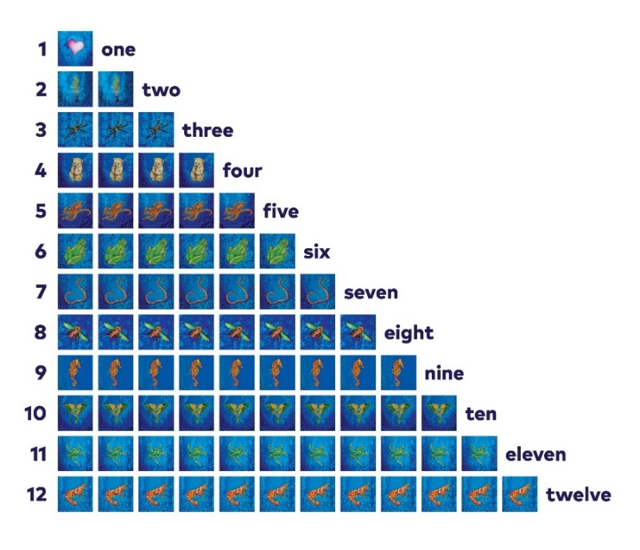

**GRAMMAR**

Each double page represents an animal or plant and an action that organism is doing. Each double page follows the same format grammatically.

***I’m glad there is a tree…growing in the world. Find two trees.***

***I’m*** is a contraction which has 2 or more words that are combined, shortened and divided by an apostrophe.***I’m*** is a contraction for ***I am***. ***I*** is a pronoun, which is a word or group of words that can substitute a noun. Like nouns, pronouns can refer to people, things and places, and ***am*** is a verb.

***glad*** is an adjective. An adjective is a word that describes a noun or pronoun.

***there*** is a adverb. An adverb modifies or limits a verb.

***is*** is a present tense linking verb.

***a*** is an article. English has 2 articles, *the* and *a* or *an*, they go before a noun.

***tree*** is a noun. A noun is a word that identifies a person, place or thing.

**…** is known as an ellipis. An ellipis is a punction mark consisting of a series of 3 dots and is used to imply a concept or the omission of text.

***growing*** is a verb. A verb is a word that shows an action, occurrence or a state of being. Verbs always tell the time or tense of the sentence.

***in*** is a preposition, which is a word or group of words, used to link nouns, pronouns and phrases to other words in a sentence, examples include *in, at, on, of, to* and *by.*

***the*** is a artricle.

***forest*** is a noun.

**.** is a full stop or period, which is a punctuation mark and is used to end a sentence.

***Find*** is a verb.

***two*** is an adjective which is a word that modifies or describes a noun or pronoun.

***trees*** is a noun.

***I’m not sad there is a bee…buzzing in the garden. Find eight bees***

As above, except,

***not*** is a

The above grammatical format and sequence can be referred to and used as an example for all 12 double pages, which cover a range of numbers, animals or plants.

**DRAMA and VERBAL DYNAMICS**

Drama and verbal dynamics can be combined together to bring the book to life. Drama, the act of performance and verbal dynamics, creating a scene through actions and voice, can be applied to all 12 double page texts. It is the children’s an interpretation of the words, through movement and sound, to convey a meaning and quality of a word. Each verb or action word used with each animal, can be acted out i.e. croaking, flying, wriggling.

**WELLBEING and POSTIVE ATTITUDES**

Wellbeing is a state of being comfortable, healthy and happy. It is obtained by looking after one’s mental and physical health. Loving Nature, yourself and other human beings are all ways of achieving wellbeing.

1. **HUMAN LOVE and the WORLD**

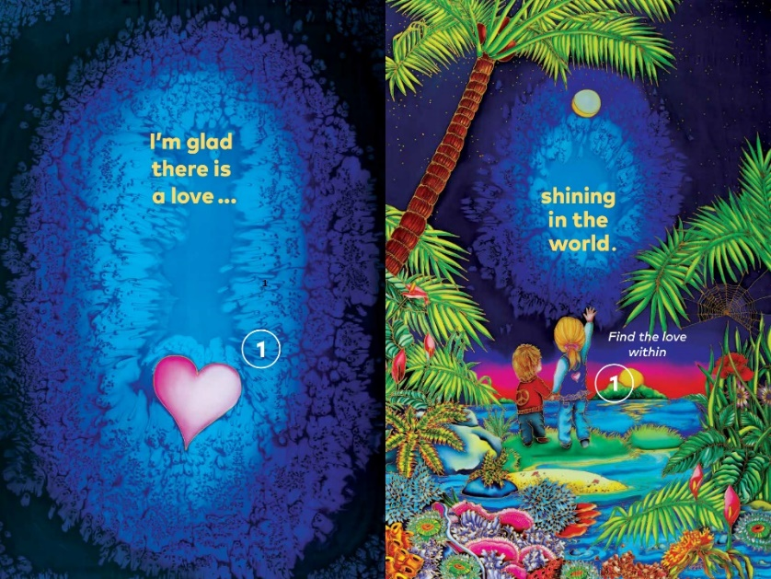

* **Animal Kingdom** Humans are **vertebrates** and belong to the **mammal** group.

Mammals are warm-blooded vertebrates and have fur or hair, females that secret milk for the nourishment of their young and give birth to live young. Humans are the most common and widespread species of primates. Humans eat both plant and animal life, making them both herbivore, plant eaters and carnivore, meat eaters. There are many properties which classify ‘being human’, like intelligence, the ability to speak a language or communicate, creativity and the ability to feel emotions like kindness, empathy and love. Nature has the power to enhance our life and it is the responsibility of human beings to protect and preserve our amazing natural world.

The 2 children pictured in the illustration represent my daughter, Casey Elle, when she was a little girl and my grandson, Leo, who is now 2 years old. My other grandson, Max, was not born when I painted this illustration.

* **Habitat and Plant Life**

The **world** is the whole of reality and everything that exists. The Earth is the name of our planet and the world is what exists on this planet alone.

The featured plant in ***Love*** are palms. Depending on the species, some palms can live for more than a century. At the cellular level, palms may be the oldest living trees because their cells are not replaced with new cells, as is the case with other trees. Many palms produce delicious fruit, like coconuts and dates. In many cultures, palms are the ultimate symbol of eternal life.

* **The Environment** Humans have impacted the natural world in many ways: overpopulation, pollution, burning fossil fuels, overfishing and deforestation. It is important we care for our local and global environment by planting more trees and flowering plants, recycling waste and growing more vegetables to eat.
* **Counting**

**1 one** The number 1 is contained in the phrase below, as the word ***the***. *Find* ***the*** *love within* The symbol of the heart is used to represent ‘love’ and can be matched from the left-hand illustration to number 1, on the girl’s t-shirt in the right-hand illustration. One heart, one love, one world, one life!

* **Grammar** (Please refer to introduction summary)
* **Drama and Verbal Dynamics**  Activity: Children spread out their arms in a circular motion, to indicate the light shining from the moon and sun, which are both featured in the illustration.
* **Wellbeing and Positive Attitudes** The natural world is an amazing place. The more time we spend in Nature, the better we feel. *Finding the love within,* refers to loving ourselves, so we in turn can love the world around us. List the activities that make the children happy when they go outside, like playing in the park, walking in the bush or on the beach, swimming in the ocean, digging in the garden or sliding down a snow hill. The two children holding hands also indicates the bond and love between the two children. The two children represented in this illustration are my daughter Casey Elle, when she was little and my grandson, Leo, who was 2, when I painted this illustration. My other grandson, Max, was not born when I completed the illustration. Family is an important part of ‘being human’. I love my daughter and grandsons, unconditionally, and being with them makes me feel very glad and not sad.

1. **TREES and the FOREST**

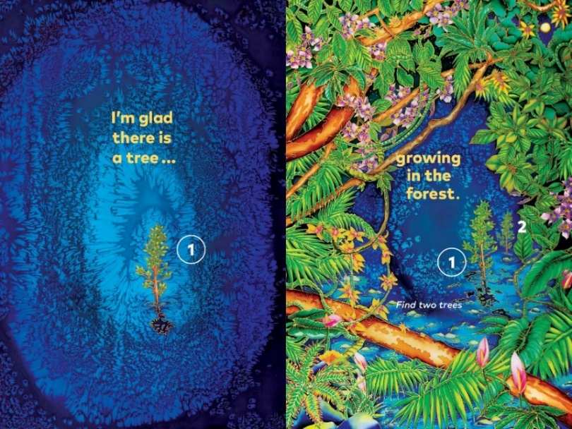

* **Plant Kingdom Trees** are the largest plants and they live the longest. They play an important role in Nature. Trees are woody plants which usually grow with a single or main stem or trunk. Trees grow wherever they can find sufficient warmth and moisture. They start their lives as a seed and as the tree gets older and larger, it produces branches. Trees help maintain the balance of gases in the atmosphere and their roots hold the soil in place. They suck up water from the ground and release it back into the air from their leaves. The tallest trees can grow to 100m. A **forest** is a large area of land covered by trees. It is estimated that forests cover approximately one third of Earth’s surface. A forest is Nature’s most efficient ecosystems. The density of the tree cover also influences the amount of sunlight and rainfall reaching each layer in the forest.
* **Habitat and Plant Life** The illustration in the book represents a tropical **rainforest**. Rainforests contain more plants and animals than any other habitat in the world. Their conservation is paramount, as they are often described as ‘the lungs of the world’ because their primary function is to filter carbon dioxide into oxygen. It is essential we grow trees and conserve forests all around the world. Forests create homes for animals, help filter gases in the atmosphere and prevent erosion by keeping the earth fertile with leaf and animal matter. The main flowers seen in the illustration are **orchids**. Orchids are one of the most exquisite rainforest flowers. It is estimated there are over 30,000 different species of flowers found in the forest.
* **The Environment**

The destruction of forests is causing severe ecological problems, as well as the extinction of thousands of different types of wildlife. To help stop the destruction we need to buy wood products from replaceable trees, use recycled paper, avoid wastage and support conservation projects which create and extend national parks. The most important thing we can do is plant more trees!

* **Counting 2 two**  There are 2 trees to find on the right-hand page. Both trees numbered 1 and 2, match the number 1 tree on the left-hand page. These are the only complete trees in the illustration. Other plant life in this illustration, include the trees’ canopy, flowers, vines and the lush undergrowth.
* **Grammar** (please refer to introduction summary)
* **Drama and Verbal Dynamics** Activity: Children curl up into a tight ball and then slowly unfurl, to rise up on their tippy toes. They then spread their arms above their heads to represent the branches of the tree, swaying in the wind. This is the act of ‘growing’ taller, just like the tree growing taller.
* **Wellbeing and Positive Attitudes** Walking in the forest is not only a mood enhancer, but it is also a wonderland of smells, sights and sounds. The rich tapestry of textures and colours can only heighten a feeling of wellbeing. Swimming under a waterfall, in the rainforest, is one of my favourite things to do.

1. **SPIDERS and the MANGROVE**

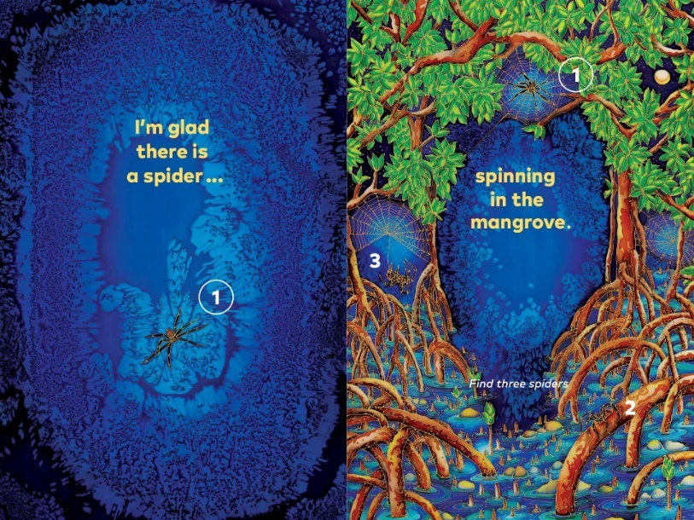

* **Animal Kingdom** Spiders are **invertebrates** and belong to a class of animals called **arachnids**. This class is a part of the phylum, Arthropoda, which is also includes insects and crustaceans. Spiders are carnivores and eat other arachnids, insects and even birds. Spiders have eight legs and 2 body parts: the head and the abdomen. Some spiders have eight eyes and have good eyesight. Most spiders spin webs to catch their prey. After the spider entraps its prey in the web, it bites its catch and paralyses it with poisonous fangs. Then it sucks the body juices from the prey, leaving only a dry skeleton. Some spiders bind their prey with silken threads. The spiders featured in the illustration are **tent spiders** and are found primarily in mangroves. They are communal species and will spin their individual webs close together. The tent spider feeds on butterflies and a variety of other insects.
* **Habitat and Plant life Mangroves** are tropical plants that are adapted to wet soils, salt water and being periodically submerged by tides. They have numerous tangled roots that grow above ground and form dense thickets. For many people mangroves look like muddy, swampy places filled with insects, reptiles and spiders, but they are essential for the good health and balance for our coastlines.
* **The Environment** Mangroves have many environmental benefits: protect water quality, provide a breeding and nursery habitat for a wide variety of birds, fish, amphibians, insects, small mammals and other aquatic fauna. Spiders also play an important role in the nurturing of ecosystems. They are ‘food’ themselves, for many vertebrate species, which feed almost exclusively on spiders.
* **Counting 3 three**

There are 3 spiders in the right-hand illustration. The number 1 spider on the left-hand illustration, matches number 1 on the right-hand illustration. One is sitting in the middle of its web, 2 is crawling along a mangrove root and 3 is dangling from a silk thread, while spinning its web.

* **Grammar** (please refer to introduction summary)
* **Drama and Verbal Dynamics** Activity: Children can spin around on the spot and then try and weave through each other, creating a web like pattern. This would be best in a large open space.
* **Wellbeing and Positive Attitudes**

Walking through a mangrove can be like going on a giant treasure hunt. Hidden within the twisted vines and branches are an amazing array of animal life. Many mangroves can now be assessed and explored by boat or boardwalks which are built above the mangroves*. I love exploring mangroves with their deep shadows and interesting root systems, it always helps me to calm my mind and soul.*

1. **BEARS and the ICE**

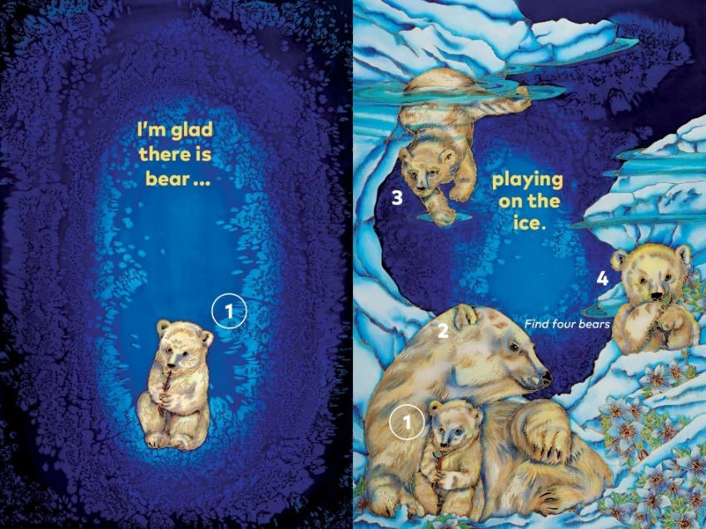

* **Animal Kingdom** Bears are **vertebrates** and belong to the **mammal** group. **Polar bears**, which are pictured in this illustration, are among the largest of the bears. They are the largest land carnivore and can reach weights of more than 455kgs and grow to 3 metres. Polar bears live around the coasts of the Artic Ocean and spend much of their time on the floating pack ice. Their thick white coats, underlaid by a layer of fat, helps to keep them warm. Unlike other bears, polar bears feed mainly on meat including seal and fish. Most female polar bears breed every third year, after separating from their young. Polar bears dig out a den in the snow and tundra where their cubs spend the first few years with their mother. This creates a very close bond between them. Female polar bears generally give birth to 2 cubs, but can sometimes have up to 4 cubs, however the mortality rate for a polar bear cub is high.
* **Habitat and Plant Life** Many different species live on the ice and tundra. The tundra is the land bordering the Artic Ocean. During the summer, some of the ice melts and plants grow. The plant featured in this illustration is known as **moss campion** or cushion pink. It is a ground hugging wildflower and stands out easily on the ice because of its vibrant colour.
* **The Environment** Temperatures in the Artic region are rising twice as fast as any other place on the Earth, due to climate change and global warming. As a result, the Artic ice is melting even faster, making it even more difficult for polar bears to survive. Some polar bears face starvation as they are unable to adapt their diets to living on land. Reducing fossil fuels and using cleaner energy sources such as solar or wind power, will help slow down the increase in temperatures around the world.
* **Counting 4 four** There are 4 polar bears playing on the ice, a mother and her 3 cubs. Cub number 1 in the right-hand illustration, matches number 1 in the left-hand illustration.
* **Grammar** (please refer to the introduction summary)
* **Drama and Verbal Dynamics** Activity: Children pretend to be a bear cub and play together by swimming in the water, chewing a stick or hiding and tumbling on the ice.
* **Wellbeing and Positive Attitudes** Being in the snow is like being submerged in a quiet, winter wonderland. The silence of the icy, snow environment has many calming properties. *Spending time in Canada, is one of my favourite places to be on a clear winter’s day, with the snow-covered mountains and frozen lakes glistening, it truly is a winter wonderland.* Polar bear cubs are also among the cutest and most playful of all newborns. Babies of any kind, usually generate feelings of love and hope.

1. **OCTOPUS and the TIDE POOL**

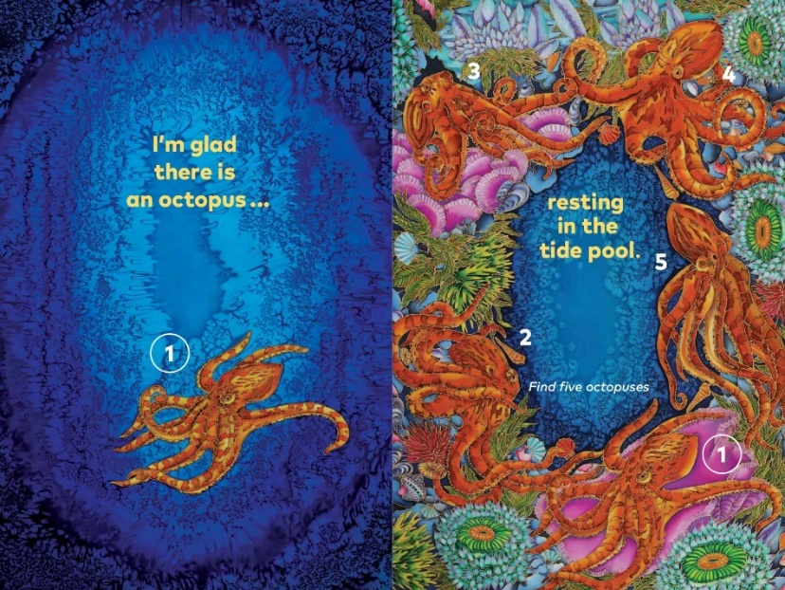

* **Animal Kingdom** An octopus is an **invertebrate** and is a soft bodied, eight limbed **mollusc** and belongs within the class of Cephalopods. The **common octopus**, pictured in this illustration, crawls along the seabed in slow motion on its eight sensitive tentacles. If startled however, they can move with a surprising burst of speed by squirting out water behind them. They make their homes in a hole, in shallow water. By day, they spend most of their time resting and hidden in their lairs. Octopuses come out at night to hunt and feed. They eat crabs, crayfish and other mollusc, however, they will eat anything they can catch.
* **Habitat and Plant Life** A **tide pool** or rock pool is a shallow pool of seawater that forms on the rocky intertidal shore. Many smaller octopuses inhabit tide pools and spend most of their time in dens, which are small holes or cervices in rocks or coral. The featured plant life in this illustration is **seaweed**. There is a wide range of seaweeds including sea lettuce, which is a bright green marine alga. Sea lettuce is extremely thin and is translucent. Unlike land plants, marine algae lack roots, stems, leaves and flowers. When looking into tide pools you will find a wide diversity of colours, shapes, textures and fascinating animals. Even though an anemone, pictured in the illustration, looks like a flower and plant, it is actually an animal.
* **The Environment** Tide pools contain a huge range of animals and plant life and provide shelter for a range of smaller creatures. Unfortunately, tide pools are impacted by many types of pollution, including discarded trash, oil spills, sewage spills and toxic chemical runoff, which all negatively impact intertidal marine life. These underwater habitats are integral to the ecology of our coastlines and it is vital we prevent the above forms of pollution.
* **Counting: 5 five** There are five resting octopuses in the tide pool. The number 1 octopus in the left-hand illustration, matches the number 1 octopus in the right-hand illustration.
* **Grammar** (please refer to the introduction summary)
* **Drama and Verbal Dynamics**

Activity: Organise the children to wave their arms and legs around like tentacles, floating in the water, before slowly floating down towards the floor, to lie in a resting position.

* **Wellbeing and Positive Attitudes**

Exploring tide pools at low tide, can uncover a fascinating world in which to escape. Being in the fresh air and discovering interesting life forms, is not only good for our minds but great for our physical fitness. As tide pools usually lie at the bottom of headlands or along tidal beaches so we need to walk to them.

1. **FROGS and the POND**

* **Animal Kingdom** A frog is a **vertebrate** and belongs to the class of **amphibians**. They are cold-blooded and females lay a large number of eggs. The eggs then pass through the tadpole stage and finally develop into baby frogs. Frogs have very smooth skins and often have poisonous glands. There are hundreds of different kinds of frogs living in almost every kind of habitat. All frogs are carnivorous and love catching and eating insects. The frogs featured in the illustration are **red-eyed tree frogs.** They make their homes within tropical lowlands, which usually has access to water, in the form of rivers or ponds. A water source is a must for their continual reproductive success.
* **Habitat and Plant Life**

**Ponds** are small, shallow, freshwater habitats that provide a home for many plants and animals. Ponds are used as breeding grounds for many different species of plant life, insects, reptiles, birds, fish and amphibians, such as frogs. The plants featured in the illustration are **waterlilies,** floating in the pond; **frangipanis** and **heliconias**, hanging over the pond and **blue irises** and **stocks**, bordering the pond.

* **The Environment**

Ponds are widely regarded as ecological hotspots for diversity. Ponds drastically increase the presence of beneficial insects. Ponds have the ability to act as a carbon sink, meaning they can capture carbon dioxide in the atmosphere and store that carbon in both land and aquatic plants. Frogs are an integral part of the food chain and throughout their life cycles, frogs occupy a vital position in the food chain as predator and prey. They keep the insect population in check. Unfortunately, frogs are disappearing. Major threats facing frogs are water pollution, the introduction of foreign fish species, loss of habitat and cane toads.

* **Counting 6 six** There are six croaking frogs to find in the left-hand illustration. Number 1 frog in the right-hand illustration, matches number 1 frog in the right-hand illustration.
* **Grammar** (refer to the introduction summary)
* **Drama and Verbal Dynamics** Activity: Children get into a crouching position, with their straight arms between their legs and their hands pressed down on to the floor. Using a springing action, they jump off their feet and hands and crouch back down while making a croaking sound like a frog.
* **Wellbeing and Positive Attitudes** Frogs come in all colours and are extremely beautiful*. Seeing a green frog or hearing them croaking in a body of water, or even in a downpipe, always brings a smile to my face.* Building your own pond or water feature in the garden is not only therapeutic, but it attracts a wonderful array of creatures. A water feature is also a good source of feng shui and calm.

1. **WORMS and THE EARTH or SOIL**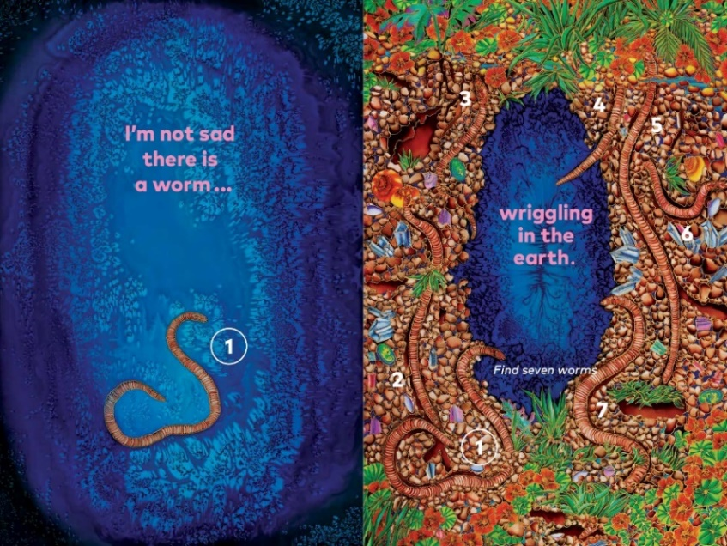

* **Animal Kingdom** Worms are **invertebrates** and belong to the classification of **Phylum Annelida**. Worms have soft bodies and do not have arms or legs and move by crawling. Worms crawl by stretching and contracting their strong muscles in their bodies. **Earthworms**, pictured in this illustration, do not have eyes, ears, teeth or lungs but they do have five hearts! Their role in the earth or dirt is vital, as they loosen, mix and oxygenate the soil as they wriggle and burrow channels. Earthworms feed on rotting plant and animal matter by swallowing soil and digesting the dead plants and animals.
* **Habitat and Plant Life** The **earth** or soil is a natural habitat for plant growth. Plant growth occurs because the soil provides essential nutrients and minerals for the plant to grow. It also provides water to plants for its metabolic process. The plants featured in the illustration are **nasturtiums**, which have brightly coloured flowers, shield shaped leaves and produce a nectar or oil, in a funnel-shaped spur at the back of the plant. The other plant featured is **grass**. Grasses are a family of plants with leaves that look like blades and grow from the base of the plant. Grasses are an important food source for many animals and help to slow erosion.
* **The Environment** Worms play a vital role in the environment, they give life to soil. These amazing burrowing creatures eat and recycle organic matter to keep the soil healthy. The intricate network of tunnels that earthworms create is extremely important too. They improve and repair soil and provide a food source for other important species. Unfortunately, earthworms are in critical decline because of loss of habitat. We need to ensure there is a healthy soil environment for the earthworm to thrive. Adding organic matter, in the form of compost, can help improve the soil moisture-holding capacity and provide a necessary food for the worm. No earthworms, no life!
* **Counting 7 seven**

There are 7 wriggling worms in the right-hand illustration. Number 1 worm in the left-hand illustration, matches number 1 worm in the right-hand illustration.

* **Grammar** (please refer to introduction summary)
* **Drama and Verbal Dynamics** Activity: The children lie on their stomachs and start crawling like a worm by stretching forward, then bending at the waist and then flattening out again. They can also wriggle around on the floor like a worm.
* **Wellbeing and Positive Attitudes**  Digging in the garden and planting vegetables or flowers is a very rewarding pastime. Getting our hands dirty in the soil can reduce depression and help us feel more relaxed. Contact with the soil triggers serotonin in our brain. Serotonin is a happy chemical and is a natural anti-depressant. It also helps strengthen our immune system.

1. **BEES and THE GARDEN**

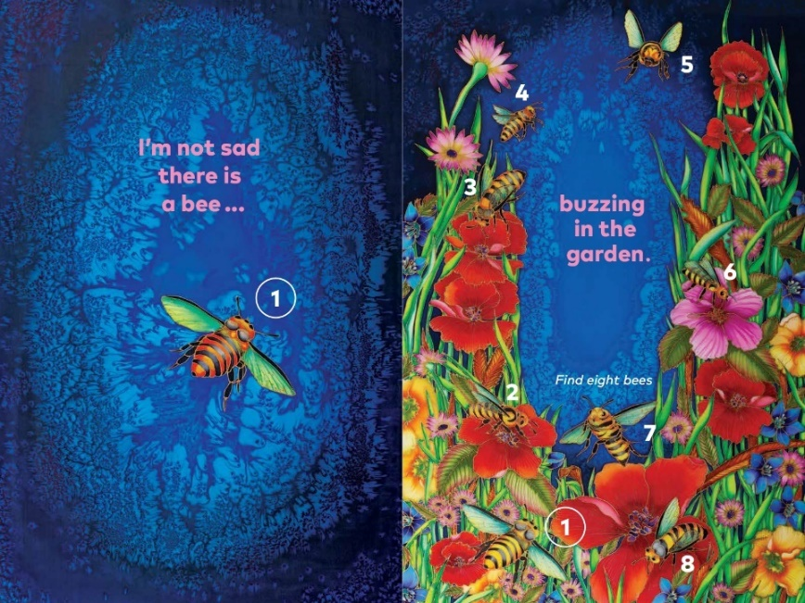

* **Animal Kingdom** Bees are **invertebrates** and belong to the class of **insects**. They have hard, outer-body exoskeletons; three body parts: a head, thorax and abdomen; three pairs of legs and two antennae. **Honeybees**, pictured in this illustration, are social insects and share the work of getting food and looking after their young. In the nest, bees have different jobs to do. Drones are male bees, whose job it is to mate with the queen bee, after which they die! The queen bee lays the eggs and the workers, who are underdeveloped females, find food and look after the young. Bees will sting if attacked, but will die in the process, as the stinger is barbed and as the bee tries to pull out, it tears its tail.
* **Habitat and Plant Life**

Flowering plants in the garden are essential for the survival of bees. Bees feed on nectar and pollen that they gather from the flowers. The flowers featured in this illustration are **poppies, daisies** and **bellflowers**. Planting more flowers in the garden will attract more bees. Bees pollinate plants, which mean they carry pollen between plants of different sexes to fertilise them. This helps the plant to reproduce and even helps plants survive by preventing inbreeding.

* **The Environment**

Bees are one of the world’s most important pollinators for food crops. Unfortunately, bee populations continue to decline, due to the use of pesticides and climate change. Without bees, there would be fewer seeds and less plant life, like clover and alfalfa, which cattle and other animals feed on to survive. This all leads to altered ecosystems. *Where would the world be without bees and their delicious honeycomb and honey?*

* **Counting 8 eight**

There are eight buzzing bees to find in the right-hand illustration. Number 1 bee in the left-hand illustration, matches number 1 bee in the right-hand illustration.

* **Grammar** (please refer to the introduction summary)
* **Drama and Verbal Dynamics** Activity: Children fly around the room, flapping their bent arms, while making a buzzing sound like a bee. Perhaps they can land on cardboard cut-outs of flowers.
* **Wellbeing and Positive Attitudes**

Flowers decrease stress, make people feel happy, promote productivity and boost your memory. Simply put, they elevate your mood. It’s hard to feel sad when you are surrounded by beauty, and flowers and their fragrance bring only joy and pleasure. Being in the garden promotes a feeling of wellbeing. A range of flowers also have healing powers. Honey from bees also provide many health benefits, including blood pressure management, wound healing, cough suppression and an antioxidant content which fights free radicals. Honey also has a high concentration of the B-Complex vitamins, including B6 and B12 and is a good source of Vitamins D and C.

1. **SEAHORSES and THE REEF**

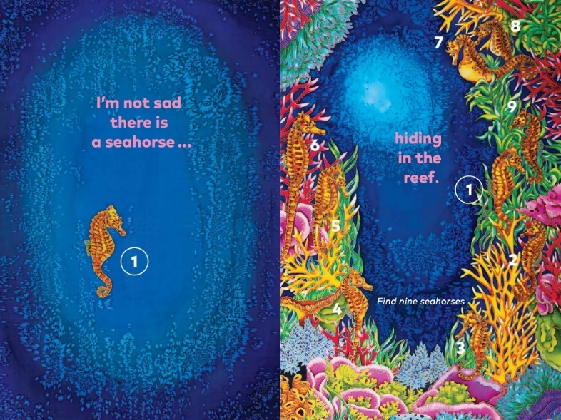

* **Animal Kingdom** Seahorses are **vertebrates** and belong to the class of **fish** and in particular, bony fish. Seahorses have many amazing qualities – male seahorses carry the babies during the reproduction cycle, they are monogamous, which means they mate with one mate. They are terrible swimmers, and they eat by suction but don’t have stomachs. Seahorses can also camouflage, and this is one of their best defences.
* **Habitat and Plant Life** Seahorses hide among seaweed and coral, and they use their camouflage to blend into the background. They use their tails to anchor themselves and then they catch the passing prey which is floating in the currents. **Seaweed**, pictured in this illustration, are large brown, red or green algae and is a favourite habitat for seahorses. Corals are not plants, as many people think, corals are actually animals. Coral reefs are the most biologically diverse environments on Earth. Reefs provide food and shelter for some of the most exotic plants and animals in the world. Reefs also protect coastlines form erosion.
* **The Environment**

Humans are the greatest threat to seahorses. The number of seahorses has drastically declined due to overfishing and intense targeted fishing. Other major threats include habitat loss, climate change and by catch. There are some very successful breeding programs around the world which are helping to stabilize numbers. Addressing rising temperatures still remains one of our greatest challenges. Coral reefs are easily damaged, and this has a devastating effect on the lifeforms that they support. Reefs around the world are under threat due a range of issues. The impact of global warming on the ocean is most visible in bleaching events, which occur much more often these days. People, as well as animals, rely on coral reefs for their livelihood. Their immense beauty attracts tourism and when managed correctly, this can actually help promote the reef’s preservation. Creating and expanding marine sanctuaries will also help protect the reef from a vast range of human impacts.

* **Counting 9 nine**  There are nine seahorses hiding in the reef in the right-hand illustration. Number 1 seahorse on the left-hand illustration, matches number 1 seahorse on the right-hand illustration.
* **Grammar** (please refer to the introduction summary)
* **Drama and Verbal Dynamics**

Activity: Children can hide somewhere in the house or classroom and then after they are found, start a discussion about what ‘camouflage’ means.

* **Wellbeing and Positive Attitudes** Improvements in human wellbeing are dependent on healthy ecosystems. Coral reefs provide jobs for local communities and offer opportunities for recreation. Thriving coral reefs may also hold the key and cure for many diseases, including cancer, arthritis and many viruses*. Snorkelling or diving on the reef is one of the best experiences I have ever had. The beauty, colour and number of different animal, fish and plant species is staggering. Being on the reef and seeing its alien like inhabitants, has undeniable positive effects, such as reducing stress, uplifting mood and promoting mindfulness.*

1. **PARROTS and THE SKY**

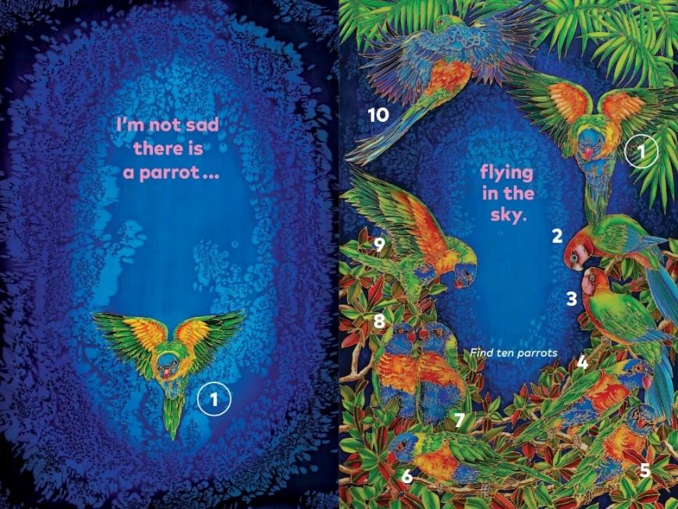

* **Animal Kingdom**

Parrots are **vertebrates** and belong to the class of **birds**. There are approximately 300 different species in the parrot family. Parrots have remarkably long lifespans. They have extremely strong beaks and eat with their feet. Some parrots also have the ability to mimic human speech. They are considered the most intelligent of all the birds. The parrots featured in the illustration are **rainbow lorikeets,** 1 and 4 - 10 and **king parrots,** 2 and 3.

* **Habitat and Plant Life**

Parrots are found in many different habitats, including tropical and temperate rainforests, deserts, grasslands and suburban backyards. They are usually found in warmer climates and live in flocks and can fly many lies each day. Parrots spend hours foraging for a variety of natural foods, socialising, communicating, bathing, preening, nesting, mating and raising their young. It is essential that forests are preserved, so parrots and birds in general, have ha place to call home. The trees featured in this illustration are the Nyssa sylvatica also known as **shade trees**. They have dark green, glossy leaves, changing in shades of red, orange and gold in autumn.

* **The Environment**

Parrots play an important role by helping to propagate the forest. Like all animals, parrots are an integral part of the ecosystem. Clear skies have minimal light pollution and smog. Smog is a type of intense air pollution. It reduces visibility and has a potential risk to human health and the animals in the environment. Both are created by humans. Clean air is vital for a healthy planet.

* **Counting 10 ten** There are ten parrots flying and roosting in the right-hand illustration. Number 1 parrot in the left-hand illustration matches, number 1 parrot in the right-hand illustration.
* **Grammar** (please refer the introduction summary)
* **Drama and Verbal Dynamics** Activity: Children flap their arms like wings and fly around the room or outdoor space, landing on a log or branch or bench. They can also breen themselves and tuck their heads under their arm like a wing, when going to sleep.
* **Wellbeing and Positive Attitudes** As an animal spirit, the parrot emerges as a symbol of communication, individuality and the power of mimicry, while illuminating our world, with its brilliant hues and vivacious energy. Some parrots make excellent companions and pets. They are sensitive, social and intelligent. They can also provide emotional support, aiding in mental health recovery. In the wild, lorikeets gather at dusk in huge numbers to roost. They gather in only a few trees and can be extremely noisy which always brings a smile to your face.

1. **TURTLES and THE BEACH**

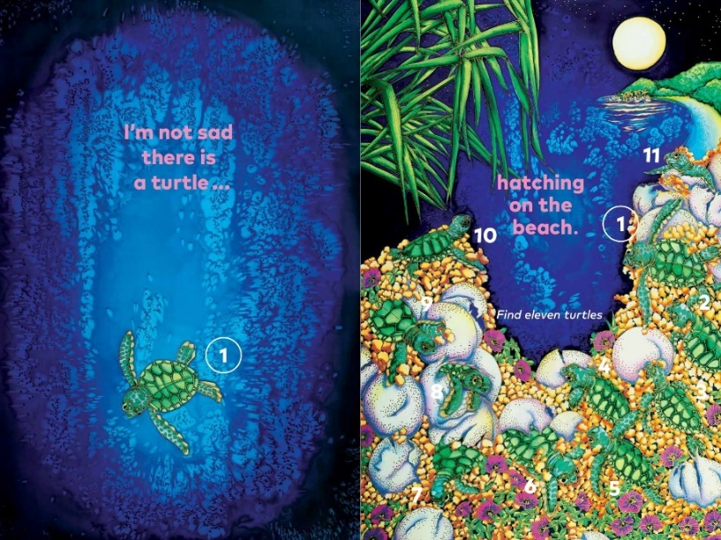

* **Animal Kingdom** Sea Turtles are **vertebrates** and belong to the class of **reptiles**. All reptiles are vertebrates. Reptiles are cold-blooded, breathe air, and lay eggs. They have shells on their backs and undersides for protection. Sea turtle’s legs have evolved over time, into flippers which help them swim. Only females go to shore to lay their eggs and they nest in the same area where they hatched. The time taken for the eggs to hatch depends on the temperature of the sand. The temperature of the sand also governs the sex of the turtle hatchlings, more males are produced in cooler sand and more females in warmer sand…cool dudes and hot chicks. When the eggs are ready to hatch, each tiny turtle breaks it shell by rubbing its ‘pip’ tooth which is on its beak on the inside of the shell. After they have broken through the sand, they burst out onto the beach together and scamper to the water. The turtle hatchlings featured in the illustration, are **green sea turtle** hatchlings.
* **Habitat and Plant Life** The diversity of shore life, reflects the dynamic and often harsh conditions found in coastal environments. Sandy **beaches** are formed where tides and currents deposit sand brought from rivers or weathered from rocky shores. Planting vegetation on the shoreline helps to protect the beach by slowing down erosion caused by the waves. The plants featured in the illustration are **pandanus**, which are palm-like trees and shrubs. The flowering plant is **beach morning glory**, which is a tough and resilient ground cover plant that helps bind the sand.
* **The Environment** The margins of the sea are one of the most diverse and challenging habitats on the planet. Keeping beaches free from litter, especially plastics, is vital for a healthy beach and a safe place for turtles to lay their eggs. Light pollution is another type of pollution threatening sea turtles. Artificial light coming from buildings along the shoreline can disorientate turtle hatchlings, by making them head towards the buildings instead of the moonlight on the water. Only one in every thousand turtles hatched will grow old enough to reproduce. Turtle habitats are being destroyed by development, feral animals, vehicles on the beach and erosion. Fortunately, a lot of people care about turtles, and they are working hard to protect their nesting grounds and devising fishing nets from which turtles can escape. Using less plastic products will also help keep our oceans clean.
* **Counting 11 eleven** There are eleven green sea turtle hatchlings hatching in the right-hand illustration. Number 1 turtle in the left-hand illustration, matches number 1 turtle in the left-hand illustration.
* **Grammar** (please refer to the introduction summary)
* **Drama and Verbal Dynamics** Activity:Children curl up in a tight ball as if they are curled up in an egg. Then using a nodding motion, their nose or imaginary pip tooth pecks at the shell until they break through. Once uncurled and lying on their stomachs, they wind their arms, around mimicking a scampering motion on the beach and head towards the sea.
* **Wellbeing and Positive Attitudes** A day at the beach is a wonderful way to have funand to marvel at the grandeur of wide, open spaces and the ocean. Walking on the beach is one of the best ways to destress and get enjoyable physical activity. Without healthy beaches there would be no nesting grounds for sea turtles. Sea turtles have been on this planet for more than 200 million years. These ancient mariners are a true testament to their survival and in many cultures, they are a symbol of spiritual rebirth and protection.

1. **PRAWNS and THE OCEAN**

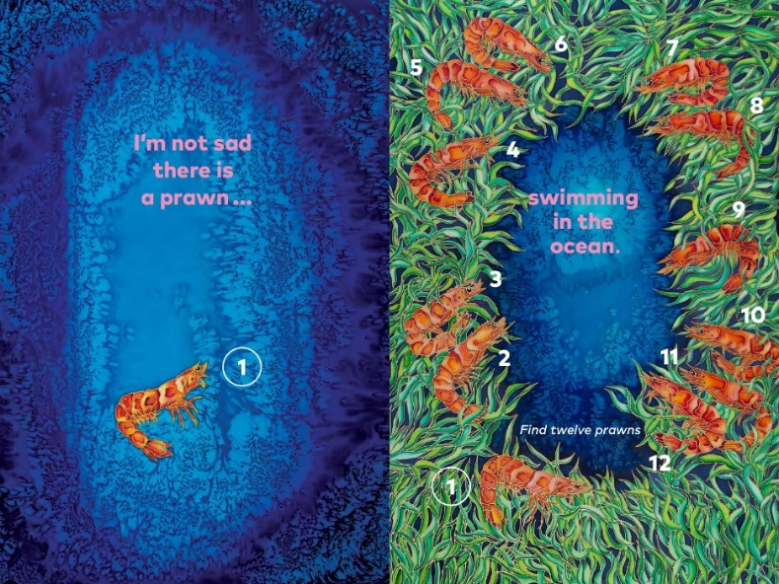

* **Animal Kingdom**

Prawns are **invertebrates** and are small aquatic **crustaceans** with an exoskeleton, some of which are edible. Another common name for a prawn is shrimp, however prawns tend to be bigger than shrimp and they taste sweeter. Both animals have ten legs, but prawns have pincers on 3 pairs of their legs, while shrimp just have one clawed duo.

* **Habitat and Plant Life** Oceans are complex environments covering 71% of the Earth’s surface. Life abounds in the water. Huge current systems transfer heat and chemicals around the Earth affecting weather both over the oceans and on land. **Seaweed** is featured in this illustration.
* **The Environment** Prawns play an essential role in the animal food chain and without their presence, food chains would be thrown out of balance. Overfishing prawns and shrimp can have a very detrimental effect on the food supply for larger sea animals like whales. Adult prawns are scavengers and, in this role, they help rid the ecosystem of dead decaying matter. Protecting our oceans is vital. We need to avoid polluting by reducing the waste and change dangerous waste, into safer waste. Healthy oceans are vital for the conservation of a wide range of sea creatures and the planet as a whole.
* **Counting 12 twelve**

There are twelve prawns swimming in the right-hand illustration. Number 1 prawn in the right-hand illustration, matches number 1 prawn on the left-hand illustration.

* **Grammar** (please refer to the introduction summary)
* **Drama and Verbal Dynamics** Activity: Children gather together in groups of twelve, then they swim together in a ‘school’ and move in a wave-like motion.
* **Wellbeing and Positive Attitudes**  On a health note, prawns are considered to be one of the healthiest foods in the world. Many people in Australia enjoy prawns on Christmas Day. It is a very communal activity, to peel and eat the prawns together.

**Swirling Text Page**

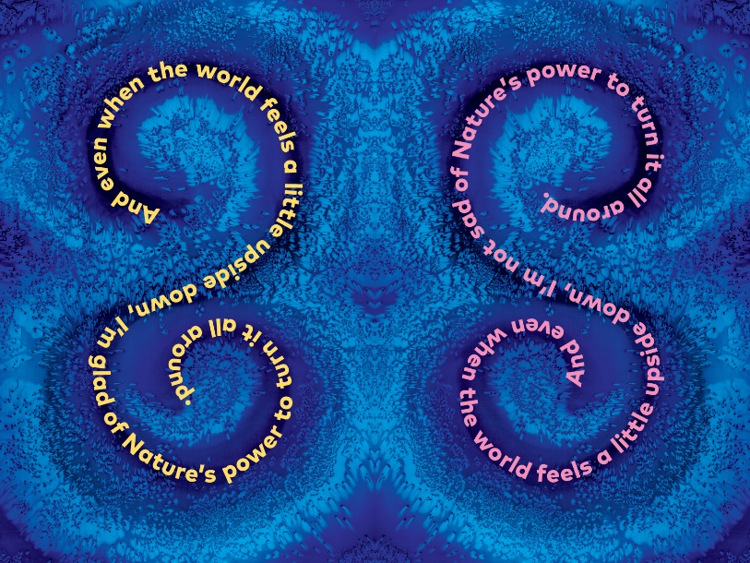

*And even when the world feels a little upside down, I’m glad of Nature’s power to turn it all around.*

Spending time in Nature equals happier and more positive moods and attitudes. When we are feeling low or sad, Nature can lift our spirits. As the Bear In The Big Blue House said, *The best thing about Nature, is being in it.*

**Back Imprint Page**

A photo of **Kim Michelle Toft** on the back imprint page, shows Kim painting one of the silk illustrations, *Flying In The Sky,* from the book.

**Author/Illustrator Background** 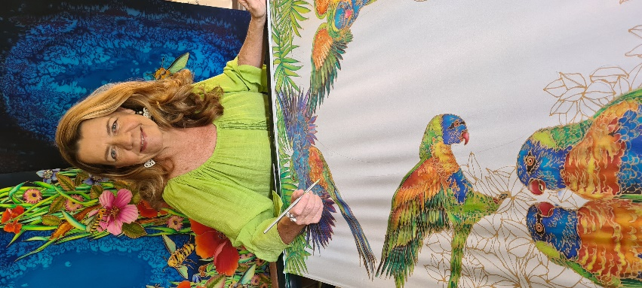

Kim Michelle Toft has been drawing since the age of four and her love of art has stayed with her throughout her ‘colourful’ life. Spanning over 44 years, Kim has been a teacher in far North Queensland, a graphic designer living on the beach in Adelaide, South Australia and a full-time marine and silk artist based in beautiful Northern NSW. For the past 32 years has been a celebrated author and illustrator. She now has her own gallery, Sea Silks Studio, in Ballina, NSW. Her multi-award winning, environmental picture books are unique, as they are illustrated with hand painted silks. Kim’s silk paintings are sold worldwide and have been purchased by some very famous people including the late Morris West, Mick Jagger and Jerry Hall. Visit [www.kimmichelletoft.com](http://www.kimmichelletoft.com) to find out more about her work.

**Kim’s Environmental Picture Books**

All Kim’s books have a strong environmental focus and reflect her love of the ocean and the coastal habitats which support it. The combination of interesting, interactive prose-style text and highly detailed hand painted silk illustrations, have made her books internationally and nationally renowned, winning many coveted awards including-

* *One Less Fish* – Honour Book - Children’s Book Council of Australia 1998
* *The World That We Want* - Honour Book - Green Earth Book Awards, USA 2006
* *A Sea Of Words* – Notable Book - Children’s Book Council of Australia 2007
* *Tick Tock Tick Tock What’s Up Croc*? - Whitley Award for Best illustrated Children’s Book - Royal Zoological Society of NSW 2010
* *Recipe For Perfect Planet Pie* – Shortlisted Golden Dragon Book Awards, Hong Kong 2014
* *Coral Sea Dreaming*: The Picture Book – Winner Best Children’s Book- Australian Wilderness Society 2019

All Kim’s books are still in print, which is a testament to their quality.

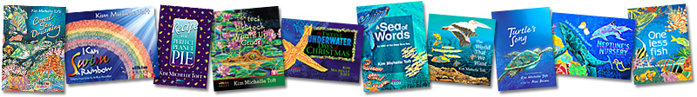

Her past titles include:

* One Less Fish *(UQP)* and *(Silkim Books)*
* Neptune’s Nursery *(UQP)*
* Turtle’s Song *(UQP)*
* The World That We Want *(UQP)*
* Reef Superstar *(Brolly Books)*
* A Sea of Words *(Silkim Books)*
* The Twelve Underwater Days of Christmas (*Silkim Books)*
* Tick Tock Tick Tock What’s Up Croc? *(Silkim Books)*
* Recipe For Perfect Planet Pie (*Silkim Books)*
* I Can Swim A Rainbow *(Silkim Books)*
* Coral Sea Dreaming: The Picture Book *(Silkim Books)*

**Silkim Books** is Kim’s publishing company and was set up 20 years ago and has published the last eight books. Each new book takes approximately 18 months to 3 years to research, draw, paint, design and produce. One hand painted silk illustration takes 2-3 weeks to create and each original silk illustration in this book, measures 120 cm x 80 cm.

Kim visits thousands of children each year throughout Australia, spreading the environmental message as well as demonstrating and teaching her unique illustration style – silk painting.

If you would like Kim Michelle Toft to visit your school, please go to her website to make an enquiry visit [**www.kimmichelletoft.com**](http://www.kimmichelletoft.com)or email Kim directly at info@kimmichelletoft.com

**The Glad Not Sad Book i**s Kim’s 12th book. She is already working on her next two books, *The Forgotten Sea* and *The Mermaids Purse*.

**Author Motivation**

*Being surrounded by nature has always sustained and nurtured me. Whether it’s diving under the waves, snorkelling on a coral reef, hiking through a rainforest or swimming under a waterfall, all of nature’s wonders continually motivate me to write and illustrate books about their preservation.*

*It has been 32 years since I wrote and illustrated my first book* ***One Less Fish.*** *This book was about the immense beauty and vulnerability of coral reefs. When I first researched this book there was 70% of reefs around the world under threat, there is now 85% endangered!*

*I always enjoy researching and providing additional information for the children to extend their knowledge. My goal is to get kids thinking about positive ways of helping this planet. Children are our future and therefore it is them who will ultimately make ‘greener’ decisions and create a better place to live. It is my wish that we all continue to nurture nature, art and education*.

Kim Michelle Toft